**Iron Chef**

**Alexander Maxey**

**Game – 334**

Take “cut the carbs” to a whole new level.  Play as an iron-clad chef saving the Kingdom of Sustenance from food monsters.  Take advantage of the situation to prepare the perfect meal with the freshest ingredients.   Augment your gear using your fallen foes to better prepare yourself for food of ever-increasing danger.  In this world, it’s eat or be eaten, and the food is hungrier than ever.

Defend the Kingdom of Sustenance as the Iron Chef, defeating food monsters that have invaded your homeland.  Take advantage of the situation to make the most delicious and exquisite meals.  Use your fallen enemies to create meals and give yourself extraordinary powers to defeat more powerful foods.

The game can be compared to Dark Souls or Breath of the Wild, in which the player views the 3D world through a 3rd Person Shooter type perspective, fighting monsters and bosses in the world. The atmosphere is bright and optimistic, with a non-serious tone.  The game’s concept is more whimsical and silly than it is serious, so it would follow that the art and audio style supports this whimsical fantasy setting. Cartoony characters, enemies and terrain paired with exciting, upbeat music should support this core concept. As the character idles or moves around the game, it should be clear he has an enthusiastic, almost bouncy spring to his step. The monsters are menacing in their size, teeth, and monstrous attributes, but are not grotesque or anxiety inducing as darker games like Dark Souls can be.

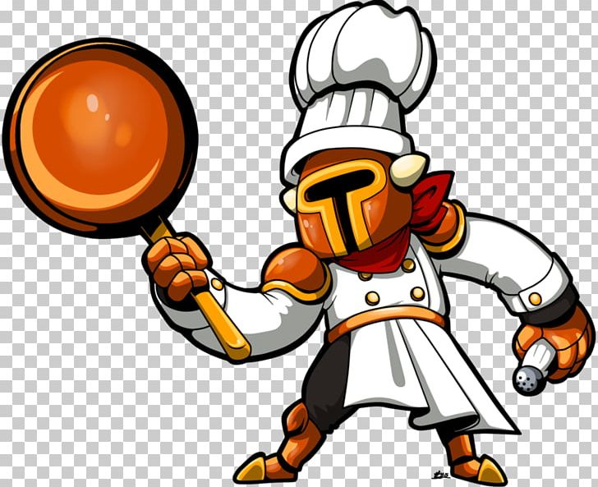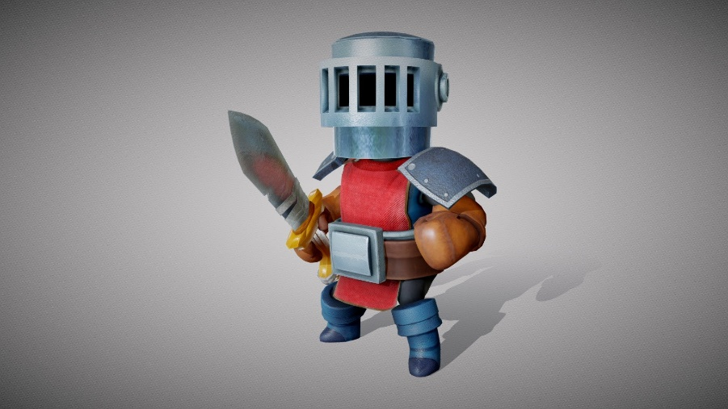Pictured here are what the models might look like, in terms of style.



Pictured here is the target player view based on other games. Viewed here: Dark Souls, Breath of the Wild, Smite

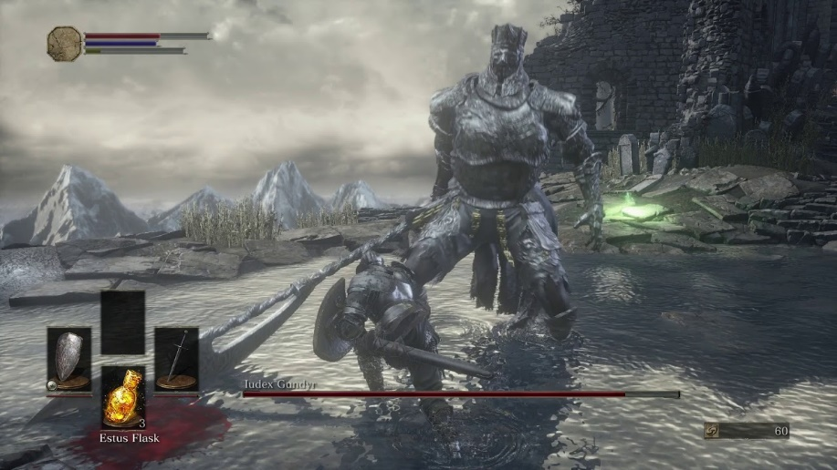

The overall goal of the game is to stop the monster invasion of the kingdom. As he travels through the land, it becomes apparent that the monsters were driven out of their home. In the final levels, the Iron Chef discovers that the Evil Vegan monsters, such as the dreaded Tofu Turkey, have taken over their land and driven them out. The Iron Chef must defeat these monsters so the original denizens can return home and leave the kingdom in peace.

On a level by level basis, the player is taking advantage of the massive food monsters’ presence to craft legendary meals from the freshest ingredients. The player must slay the monsters present in the level to craft the perfect meal, such as an omelet or a soup. By killing an enemy, the monster is absorbed into their dish, thereby adding it to the meal. They must ensure they do not add too much or too little of an ingredient and avoid ingredients that don’t go in a dish. One required ingredient will be acquired by defeating a mighty boss. The player will be scored at level’s end based on how well they crafted the dish. A minimum score is required to progress to the next level.

The end goal for the game will be to publish to Steam and the Xbox store. If PlayStation becomes a friendlier development space, we will investigate publishing to that platform as well. A projected price point will be somewhere in the $5-$20 range, as I do not believe a free to play with DLC/In Game Store is a viable money-making strategy for this game.

The games targeted audience is the teenage to young adult demographic. We are targeting people who enjoy the combat/game style of Dark Souls but are looking for a more casual/non-serious experience. A younger audience generally shies away from a game like Dark Souls, however the game has a similar lighter tone to Breath of the Wild, so we can attract the younger teen audience as well. The game will likely be rated T for teen due to the cartoonish violence.

The game will be structured in levels, following a linear path. Before a level begins and when a level ends, a quick dialogue or cutscene might play to help further the narrative, similar to the way Dungeons 3 has 2D art with a narrator explaining events between some levels.

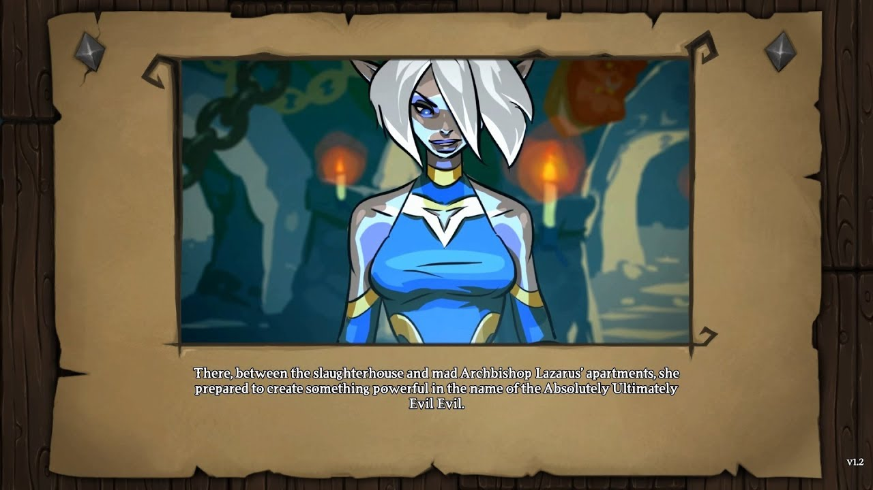

The levels encountered will be structured into different sub-groups, like stages in other games. These might be food groups or meal types, like breakfast lunch or dinner. In this way we can theme our levels and environments, such as a morning light for the breakfast levels, a dark spooky forest for the midnight snack levels, etc.

The game will likely only have 1 difficulty mode, however if we feel the game could use harder or easier difficulties, we can adjust enemy HP, speed, attack power, and attack timers based on an attribute. Should we choose to include harder difficulties, the game will be designed around the “Medium Difficulty” with easy and hard modes being tuned later in development.

The Main menu can lead to the Level Selector, the Setting Screen, or the Controls screen. When a level is selected from the Level Selector, the player will get to choose their augmentation and costume (if any).

The gameplay can be compared to Dark Souls or Breath of the Wild. The player must explore the level, fight the monsters found in the level, and defeat a powerful boss. The game begins to differentiate in that the player must think about what they kill to make the perfect dish, and that the world is much less open, and more level based.

The game’s combat, much like the stated comparison games, has the player jog, sprint, jump, duck, and roll to move around the level and evade enemy attacks. The player will have two basic attack forms, a basic melee attack, and a basic ranged attack. By default, this will be swinging your cleaver and throwing a frying pan. The player will also have an augmentation power, which will be acquired throughout the different levels and chosen at the level’s start. This might be a passive effect to make you stronger, or an active effect like an attack, buff, or debuff.

Outside of combat, the player will explore the level, looking for the food types they need and the eventual boss. The player can also decide to eat some of the ingredients they gathered to restore some hit points. The player can only do this so many times in a level, so they must be careful when they use it and what ingredient they choose to eat. The player’s will eventually return to their cauldron at the start point, so they can conclude the level.

The player will encounter several different types of enemies. Most enemies will have their basic dodgeable attack, and perhaps one or two powers, and will be required for your dish. Some of these enemies will not be a required component for your dish and killing them will give a detriment to your final score. These enemies will usually be avoidable in some way, such as being big and slow so the player can go around, or not damaging to the player, and merely a nuisance, so the player can choose to deal with the annoyance rather than kill the monster. There will be one boss in every level, each one with a unique power set, such as an egg that can roll and bounce around his fight area.

After a level is completed, the game will evaluate what the player collected for the level. The player will then be scored based on how well they did, and if the minimum score is met, the player will be ready to advance to the next level and may unlock a new augment for future levels.

This gameplay is unique to its counterparts due to the fact that there is a punishment for killing too many enemies or the wrong enemies, requiring the player to strategize and work around instead of purely hacking and slashing. In addition, the game is more level oriented than open world, leading to a more contained and controlled game experience.

To create this game, the team will require 3-5 programmers. As I am a programmer myself, this reduces the need to 2-4 more programmers. The game is 3D, so 3D modelers will be of the utmost importance. 3—5 should be enough to get what we need. If the modelers do not know how to animate, we will need 2-4 animators to animate the models created, or we will need the modelers to learn how to do this. We will need 1-3 audio members to work on soundtracks and sound effects. Finally, 1-3 Graphics/Effects artists would help with 2D images for transitions and particle effects in the game.

To summarize the needs:

2-4 Programmers (plus myself)

3-5 3D Modelers

2-4 3D Animators (Dependent on modeler skillsets)

1-3 Audio Makers

1-3 2D/Effects Artists

Our technical requirements should be mostly met but will depend on the skillset of the team. We will use Unity as the game engine, without compromise. Within Unity, we will make use of the Cinemachine system to operate the player camera and NavMesh AI to control enemy movement. For modeling and animation, we will use either Blender or Maya, depending on what the team is most comfortable with. For audio tools, this will also depend on what the team is comfortable with, however we can grab a lot of sound clips from StoryBlocks and can edit them in Audacity should the need arise. We will use GitHub as our version/file control.

This game is based on the 2D Game “Iron Chef” produced in Game 222. A sample level can be found here: <https://github.com/Zrak55/AlexMaxeyProjects/tree/master/Iron%20Chef>